**Introduction**

* An investment strategy is a set of principles that guide investment decisions. There are several different investing plans you can follow depending on your risk tolerance, investing style, long-term financial goals, and access to capital, Investing strategies are flexible. If you choose one and it doesn’t suit your risk tolerance or schedule, you can certainly make changes.
* However, changing investment strategies come at a cost. Each time you buy or sell securities—especially in the short-term in non-sheltered accounts—may create taxable events. You may also realize your portfolio is riskier than you'd prefer after your investments have dropped in value.
* Trade signals can provide information on whether to enter or exit a trade and the best time to do it. The signal can combine one or more factors to form a single trigger.
* The analysis considers a variety of factors like price, volume, market sentiments, historical data, etc., to form predictions of stock market trends called technical indicators. One can opt to incorporate one or more [**technical indicators**](https://www.wallstreetmojo.com/technical-indicator/) to try and reduce the risk of making a trade. However, the resultant tool might be complex and counterproductive with too many technical indicators.

**Literature Review**

While a number of studies were undertaken to understand the nature of the relationship between financial development and economic growth, only a few included the role of stock markets in the economic development process. The absence of accurate stock market development indicators was one of the many reasons why a majority of the studies used bank measures of financial development and ignored the role of stock markets in such studies. But, more recently the availability of more appropriate data has increased the scope for research in this field. In spite of this, debate still exists over the nature of the relationship between stock market and economic development, with many studies attributing a healthy stock market to slow economic growth.

**Dataset Description**

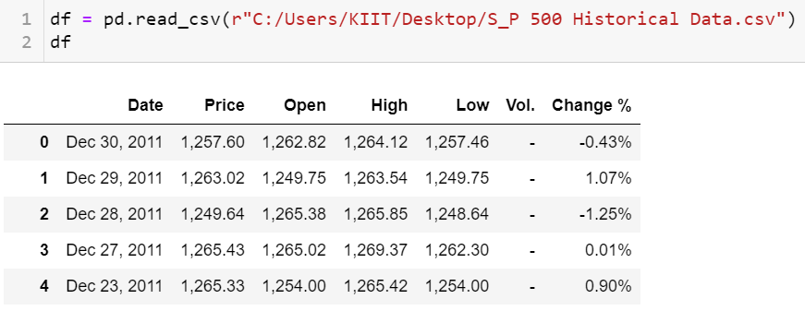

The Given Dataset consists of some column named as :

* Date
* Price
* Open
* High
* Low
* Vol
* Change %

**Date :** This is the column which stores the actual date from the past .

**Price :** This is the column which stores the Price of the Stock on the current Date.

**Open :** This is the Column which stores the Price at which the stock has been opened to be bough on the actual day.

**High :** This is the column which stores the Highest Price the Stock as Achieved on that particular day.

**Low :** This is the column which stores the Lowest Price the Stock has been degraded to on that particular day.

**Vol :** Stores NULL Values across the Dataset.

**Change % :** This is the column which shows the change in the price during the day of a particular stock in percentage.

**Methodology**

* Some of the best trade signals are Moving average convergence divergence (MACD), Simple moving average, Stochastic indicator, Exponential moving average (EMA), Relative strength index (RSI), etc.
* In our case we have used Simple Moving Average to identify the market trend.
  + Simple Moving Average: This is a common trend-following trading indicator that new traders use regularly. The SMA shows lagging indicators clearly and is especially useful in showing the market’s direction. The latter can sometimes not be clear when looking at real-time graphs. One of the characteristics of the SMA is that it utilizes simple moving averages to produce the output.

**Results :**

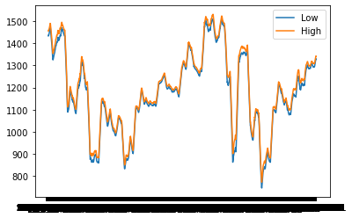

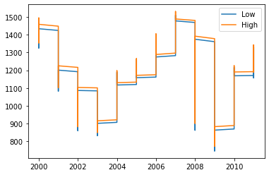

**Commulative Return over a Set time-period**

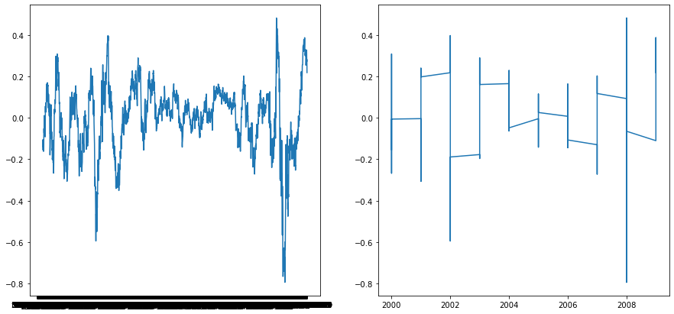

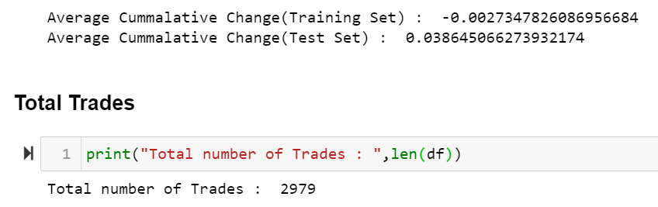

**Conclusions**

Traders who are using a basing period to find an entry point in a trending market should place a trade when price breaks above the high of the consolidated range (for a long position). The breakout should occur on above-average volume to show participation in the move. Ideally, a commonly used moving average, such as the 20-day or 50-day, acts as support at the bottom of the basing period; this allows the moving average to catch up to price. The moving average acts as resistance for a short position.

The narrow range of a basing formation allows for a healthy risk/reward ratio. Traders can place a stop-loss order below the lowest traded price in the basing period. Since the expectation is for the market to start trending again, profit targets that are many multiples of the stop amount can be set to capture the bulk of the move.

**Refrences :**

<https://www.wallstreetmojo.com/trade-signal/>

<https://www.investopedia.com/terms/b/basing.asp#:~:text=What%20is%20Basing%3F,looks%20flat%2C%20or%20slightly%20rounded>.

<https://www.investopedia.com/terms/b/basing.asp#:~:text=What%20is%20Basing%3F,looks%20flat%2C%20or%20slightly%20rounded>.

<file:///C:/Users/KIIT/Desktop/StockMarketsOverviewandLitReviewMPRA_paper_101855.pdf>

**Distribution of Work**

|  |  |
| --- | --- |
| **1st Student Name** | **2nd Student Name** |
|  |  |
|  |  |
|  |  |
|  |  |
|  |  |
|  |  |